**Business Case: Target SQL**

**Submitted by: Tanisha Singhal**

**Description of Problem Statement:** Assuming you are a data analyst/ scientist at Target, you have been assigned the task of analyzing the given dataset to extract valuable insights and provide actionable recommendations.

Q1. **Import the dataset and do usual exploratory analysis steps like checking the structure & characteristics of the dataset:**

1. **Data type of all columns in the "customers" table.**

**Query:**

SELECT

column_name,

data_type

FROM Target.INFORMATION_SCHEMA.COLUMNS

WHERE table_name = "customers"

**Output:**

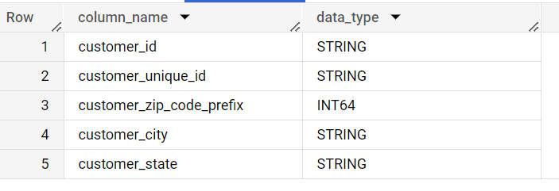

**Insights:**

This implies that

* customer_id, customer_unique_id, customer_city, and customer_state: are stored in STRING data type. Thus it can be of the type Char or Varchar.
* Customer_zip_code_prefix: is stored in INTEGER data type. This implies that it represents a whole number having a size of 64-bits.

1. **Get the time range between which the orders were placed.**

**Query:**

SELECT

MIN(order_purchase_timestamp) AS MINIMUM_TIME,

MAX(order_purchase_timestamp) AS MAXIMUM_TIME

FROM `Target.orders`

**Output:**

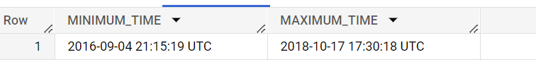

**Insights:**

The above output signifies the minimum and maximum time of the order placed.

Thus it gives us the information that the first order was placed on “2016-09-04 21:15:19 UTC” and the last order was placed on “2018-10-17 17:30:18 UTC”.

**// Extra Data Analysis**

**Extending this question further, we can calculate the time range for the orders that each customer has placed.**

**Query:**

SELECT

customer_id,

MIN(order_purchase_timestamp) AS MINIMUM_TIME,

MAX(order_purchase_timestamp) AS MAXIMUM_TIME

FROM `Target.orders`

GROUP BY customer_id

**Output:**

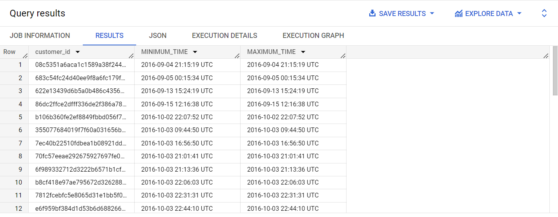

**Insights:**

The above data signifies the minimum and maximum time of the order being placed by each customer.

In other words, it gives us information about the first and the last order placed by each customer.

1. **Count the number of Cities and States in our dataset.**

**Interpretation:** To count the total number of Cities and States.

**Query:**

SELECT

COUNT(DISTINCT customer_city) AS TotalCities,

COUNT(DISTINCT customer_state) AS TotalStates

FROM `Target.customers`

**Output:**

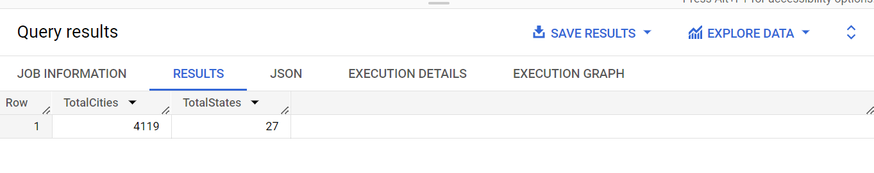

**Insights:**

This implies that in our dataset of Brazil, there are a total of 4119 Cities and 27 States.

**// Extra Data Analysis**

**Extending this question further, we can have the Cities and States of the customers who placed an order.**

**Query:**

SELECT

c.customer_id,

c.customer_city,

c.customer_state

FROM `Target.customers` as c

INNER JOIN `Target.orders` as o

ON c.customer_id = o.customer_id

ORDER BY c.customer_city, c.customer_state

**Output:**

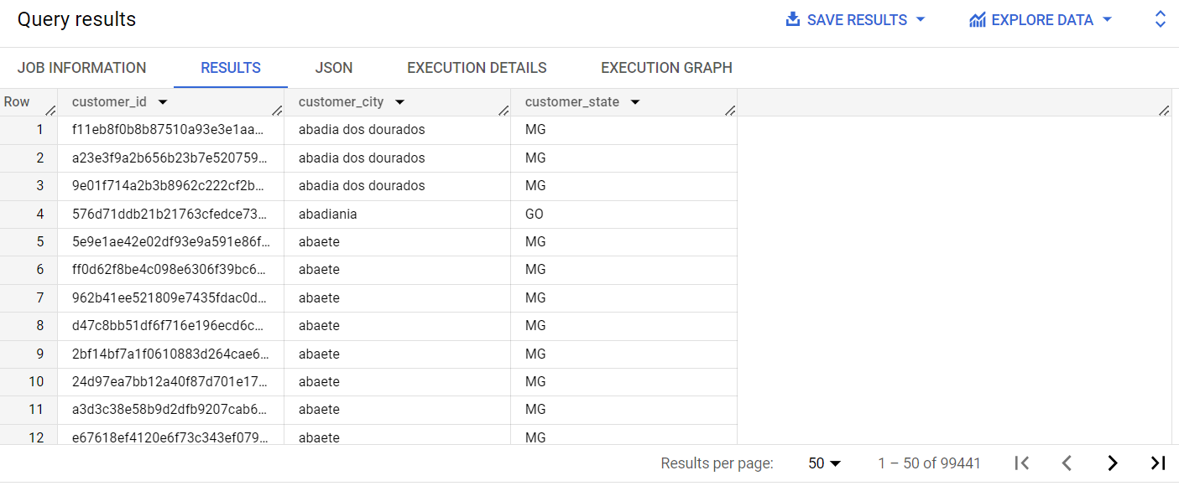

**Insights:**

The above output gives us the information of each customer and their respective City and State.

**Q2. In-depth Exploration:**

1. **Is there a growing trend in the no. of orders placed over the past years?**

**Query:**

SELECT

EXTRACT(YEAR from order_purchase_timestamp) AS Year,

COUNT(*) as orders_placed_per_year

FROM `Target.orders`

GROUP BY Year

ORDER BY Year

**Output:**

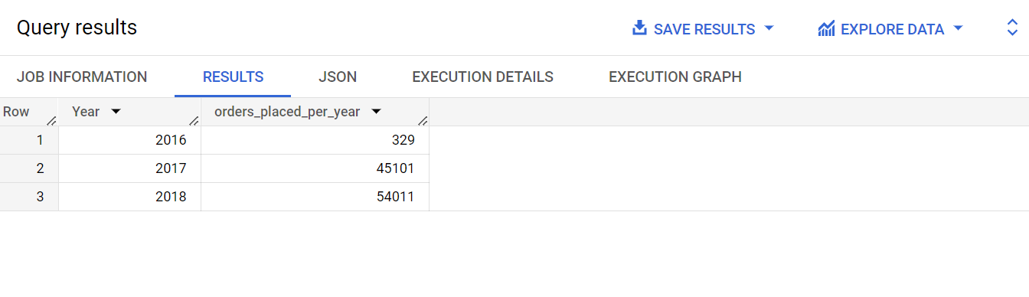

**Insights:**

Yes, there is a growing trend in the number of orders placed over the past years.

* The number of orders placed by the customers is increasing per year. It was 329 in the year 2016 → 45,101 in the year 2017 → 54,011 in the year 2018.

Thus, the total orders placed were: 99441

* It should be noted that the orders placed in 2016 are significantly less than the following years because the orders placed in 2016 are calculated from the month of September.

1. **Can we see some kind of monthly seasonality in terms of the no. of orders being placed?**

Yes and we can approach this question in two ways.

**Approach: Calculating the number of orders being placed for months, irrespective of the year in our dataset.**

**Query:**

SELECT

EXTRACT(MONTH from order_purchase_timestamp) AS Month,

COUNT(*) as orders_placed_per_month

FROM `Target.orders`

GROUP BY Month

ORDER BY Month

**Output:**

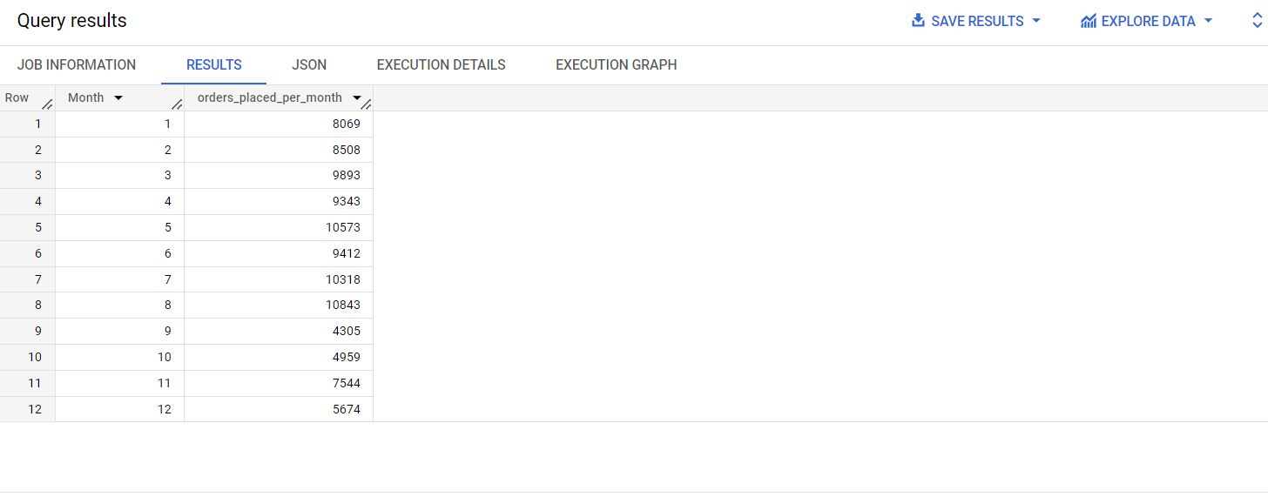

**Insights:**

Below is the graph drawn for the obtained data which represents the number of orders placed per month.

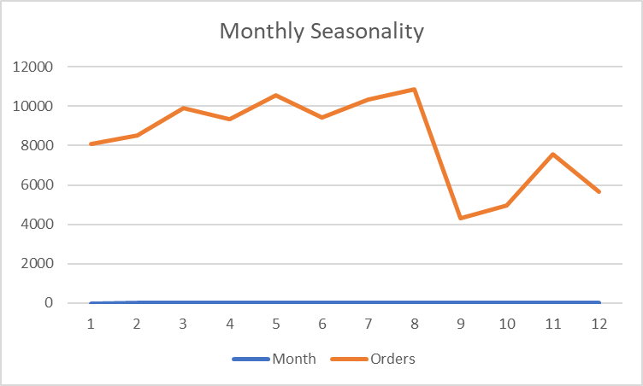

* It can be seen that comparatively a large number of orders are placed from the months January to August.
* The highest number of orders is placed in the month of August. It could be because July is generally the **coldest month** in Brazil. Thus, with the season changing from June to July to August, the number of purchases must have increased as the customers must have bought winter wear.
* With the **start of the new year**, the number of orders placed is increasing from December to January. Brazilian’s celebrate their holidays with enthusiasm and the purchases of items like clothes, food and beverages, cleaning supplies, home decor, etc. increases simultaneously.
* It could also be due to the fact that **one of the batch of colleges in Brazil starts in the month of February to June**. Thus, students purchase their college supplies at reasonable prices from target.
* Between the end of February or the start of March, one of the **most famous holidays** of Brazil, the Carnival, is celebrated. Locals celebrate and make purchases. This could be one of the reasons for the increase in purchases in the months of February and March.
* The month of November can also be seen with a little increase in the number of orders. This could be due to the **holidays falling in this month like, Brazil’s Republic day, All’s Souls’ day, and the most important black friday.**

**// Extra Data Analysis**

**Extending this question further, we can calculate the orders placed per month per year.**

**Query:**

SELECT

EXTRACT(Year from order_purchase_timestamp) AS Year,

EXTRACT(MONTH from order_purchase_timestamp) AS Month,

COUNT(*) as orders_placed

FROM `Target.orders`

GROUP BY Year, Month

ORDER BY Year, Month

**Output:**

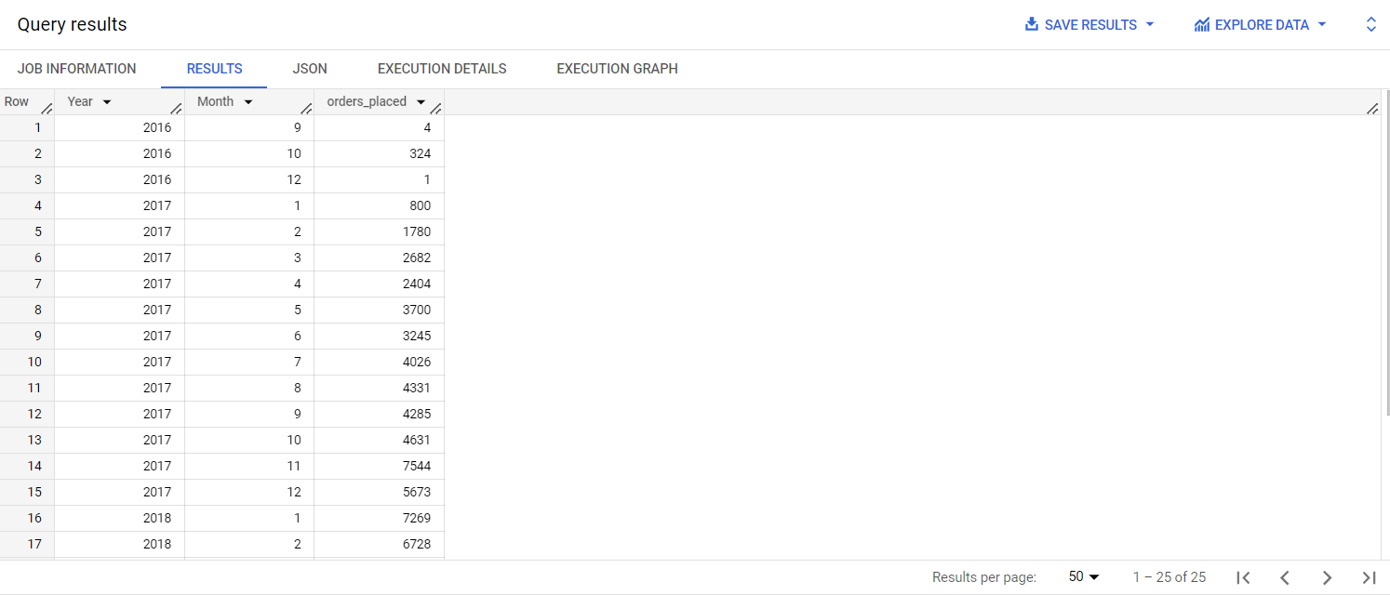

**Insights:**

The above data set gives us the further breakdown of the number of orders placed in each month of the respective years.

1. **During what time of the day, do the Brazilian customers mostly place their orders? (Dawn, Morning, Afternoon or Night)**
   * **0-6 hrs : Dawn**
   * **7-12 hrs : Mornings**
   * **13-18 hrs : Afternoon**
   * **19-23 hrs : Night**

**Query:**

SELECT

t2.Day_time,

SUM(t2.orders_placed) as orders_placed_during_day

FROM (

SELECT

t.orders_placed,

CASE

WHEN t.hour_of_day BETWEEN 0 AND 6

THEN "DAWN"

WHEN t.hour_of_day BETWEEN 7 AND 12

THEN "Morning"

WHEN t.hour_of_day BETWEEN 13 AND 18

THEN "Afternoon"

WHEN t.hour_of_day BETWEEN 19 AND 23

THEN "Night"

END AS Day_time

FROM (

SELECT

EXTRACT(Hour from order_purchase_timestamp) AS hour_of_day,

COUNT(*) as orders_placed

FROM `Target.orders`

GROUP BY hour_of_day) as t)

as t2

GROUP BY t2.Day_time

ORDER BY orders_placed_during_day DESC

**Output:**

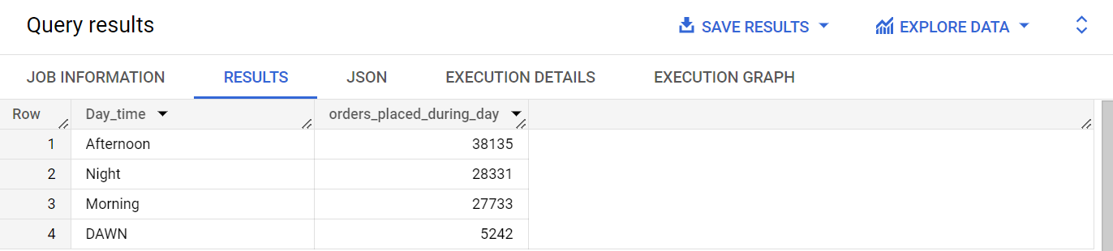

**Insights:**

This output gives the distribution of orders throughout the different times of the day.

* Customers in Brazil place most of their orders in the afternoon i.e. between 13-18 hrs. Thus, these are the most active hours in terms of the number of orders being placed.
* Considerable portion of customers also place their orders at night or late-evening hours i.e. between 19-23 hrs.
* This is followed by morning where a lowered number of orders is placed when compared to afternoon and night hours. Thus, some customers prefer to start their day by placing an order but not many.
* Lastly, there are customers who place their order at dawn where fewer customers engage in shopping. Also, this contains the time where most of the customers might be sleeping.

**Q3. Evolution of E-commerce orders in the Brazil region:**

1. **Get the month on month number of orders placed in each state.**

**Query:**

**(Approach: calculating the number of orders placed in each state irrespective of the year)**

SELECT

c.customer_state,

EXTRACT(MONTH from order_purchase_timestamp) AS Month,

COUNT(*) as orders_placed_per_month

FROM `Target.orders` as o

INNER JOIN `Target.customers` as c

ON c.customer_id = o.customer_id

GROUP BY Month,c.customer_state

ORDER BY c.customer_state, Month

**Output:**

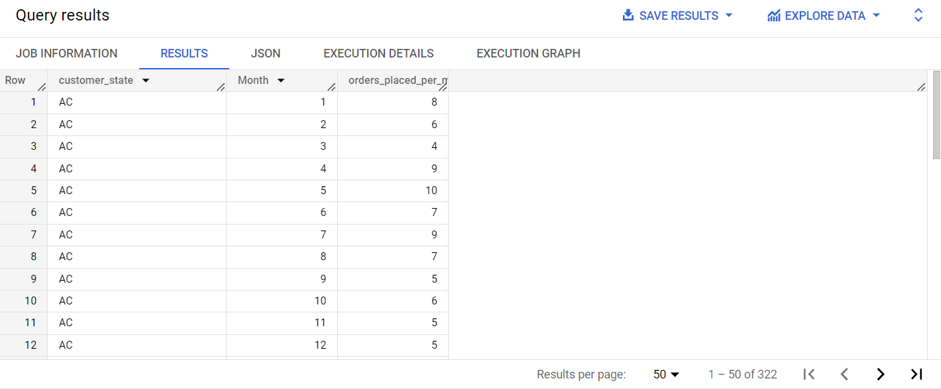

**Insights:**

The above query gives us the seasonal demands in each region. Also, tracking the month on month orders can help us evaluate the customer’s engagement and satisfaction. Growing or consistent number of orders placed will imply satisfied customers whereas, the declining number of orders placed suggests potential issues which should be evaluated and resolved with the help of suitable strategies.

The trend here is also similar to what we observed in the monthly seasonality trend. Months like September, October, November, and December have fewer orders placed.

**// Extra Data Analysis**

**Extending this question further, we can calculate the orders placed in each state each year.**

**Query:**

SELECT

EXTRACT(YEAR from order_purchase_timestamp) AS Year,

EXTRACT(MONTH from order_purchase_timestamp) AS Month,

c.customer_state,

COUNT(*) as orders_placed_per_month

FROM `Target.orders` as o

INNER JOIN `Target.customers` as c

ON c.customer_id = o.customer_id

GROUP BY Year, Month,c.customer_state

ORDER BY Year, Month, c.customer_state

**Output:**

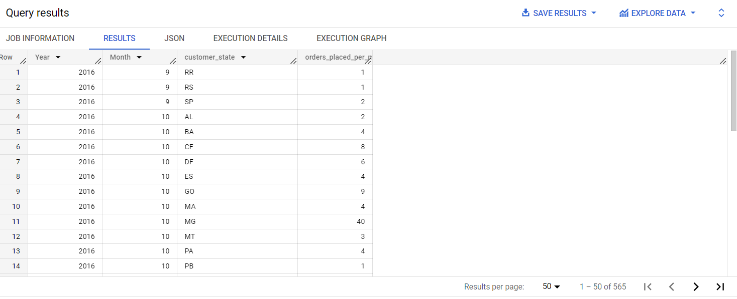

1. **How are the customers distributed across all the states?**

**Query:**

SELECT

customer_state,

COUNT(DISTINCT customer_id) as number_of_customers

FROM `Target.customers`

GROUP BY customer_state

ORDER BY number_of_customers DESC

**Output:**

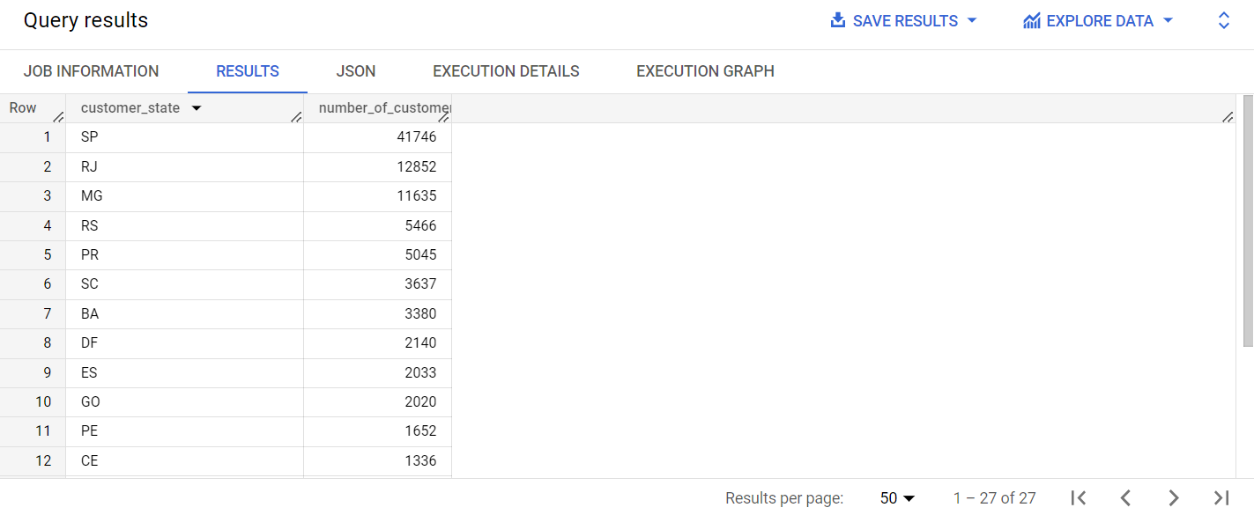

**Insights:**

* This output gives us very crucial information about the geographic reach of the company. It gives information about the distribution of customers across different states in Brazil. There is a significant variation in the number of customers from 41746 in the State SP to 46 customers in the State RR.
* Thus, while planning marketing campaigns, business growth, customer acquisition operations and other important strategies, this information will be kept in mind and the ways to increase the number of customers in the lower numbered states will be thought of.

**Q4. Impact on Economy: Analyze the money movement by e-commerce by looking at order prices, freight and others.**

1. **Get the % increase in the cost of orders from year 2017 to 2018 (include months between Jan to Aug only).  
   You can use the "payment_value" column in the payments table to get the cost of orders.**

**Query:**

SELECT

t.year,

SUM(t.payment_value) as cost_of_orders,

ROUND(((SUM(t.payment_value) - (LAG(SUM(t.payment_value)) OVER(ORDER BY t.year)))/(LAG(SUM(t.payment_value)) OVER(ORDER BY t.year)) * 100),2) as percentage_increase

FROM (

SELECT

EXTRACT(Year from o.order_purchase_timestamp) as year,

EXTRACT(Month from o.order_purchase_timestamp) as month,

p.payment_value

FROM `Target.orders` as o

INNER JOIN `Target.payments` as p

ON o.order_id = p.order_id) t

WHERE (t.year=2017 OR t.year=2018) AND (t.month BETWEEN 1 and 8)

GROUP BY t.year

ORDER BY t.year

**Output:**

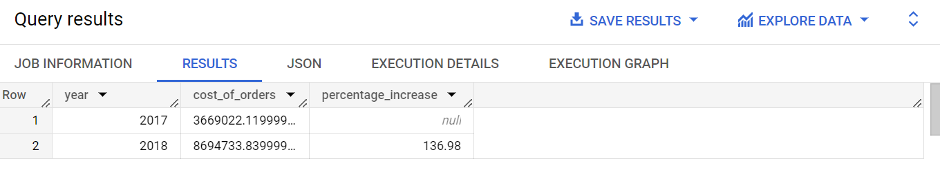

**Insights:**

The percentage increase in the cost of orders reflects the revenue growth of orders for the period 2017 to 2018.

There is an increase of 136.98% in cost of orders from the year 2017 to 2018. This could be due to various reasons including market demand, profitability, market competition, new additions in the product etc.

Important thing to consider here is the customers’ perspective. It is very important to find out if the customers will find this increase reasonable and if they are willing to pay the increased price.

1. **Calculate the Total & Average value of order price for each state.**

**Query:**

SELECT

c.customer_state,

ROUND(SUM(p.payment_value),2) as Total_order_price,

ROUND(AVG(p.payment_value),2) as Average_order_price

FROM `Target.payments` as p

INNER JOIN `Target.orders` as o

ON p.order_id = o.order_id

INNER JOIN `Target.customers` as c

ON o.customer_id = c.customer_id

GROUP BY c.customer_state

ORDER BY Total_order_price DESC,Average_order_price DESC

**Output:**

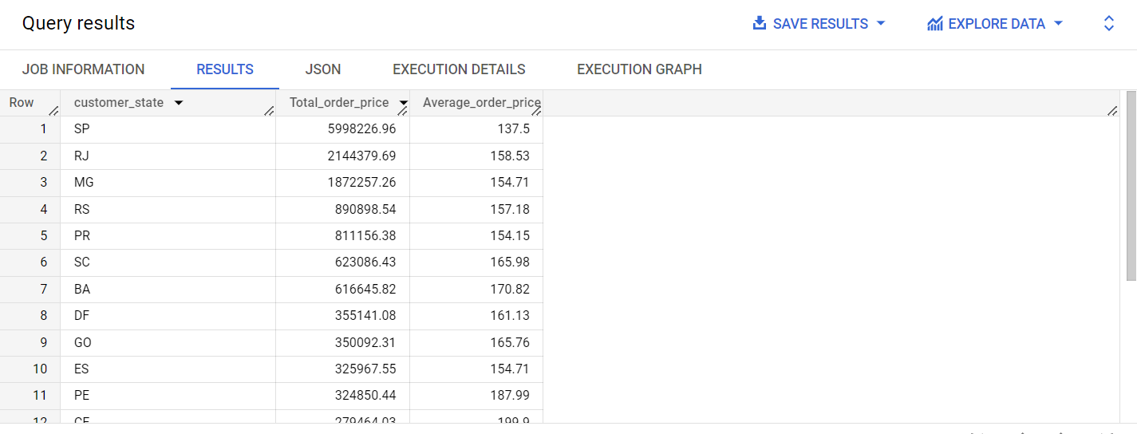

**Insights:**

Analysing the total and average value of order prices for each state will help in identifying the regions where the customers are willing to spend more or less on their orders placed. This will help in understanding the customers’ behaviour. The above data is sorted in descending order for both total and average order price for each state.

1. **Calculate the Total & Average value of order freight for each state.**

**Query:**

SELECT

c.customer_state,

ROUND(SUM(oi.freight_value),2) as Total_order_freight,

ROUND(AVG(oi.freight_value),2) as Average_order_freight

FROM `Target.order_items` as oi

INNER JOIN `Target.orders` as o

ON oi.order_id = o.order_id

INNER JOIN `Target.customers` as c

ON o.customer_id = c.customer_id

GROUP BY c.customer_state

ORDER BY Total_order_freight DESC,Average_order_freight DESC

**Output:**

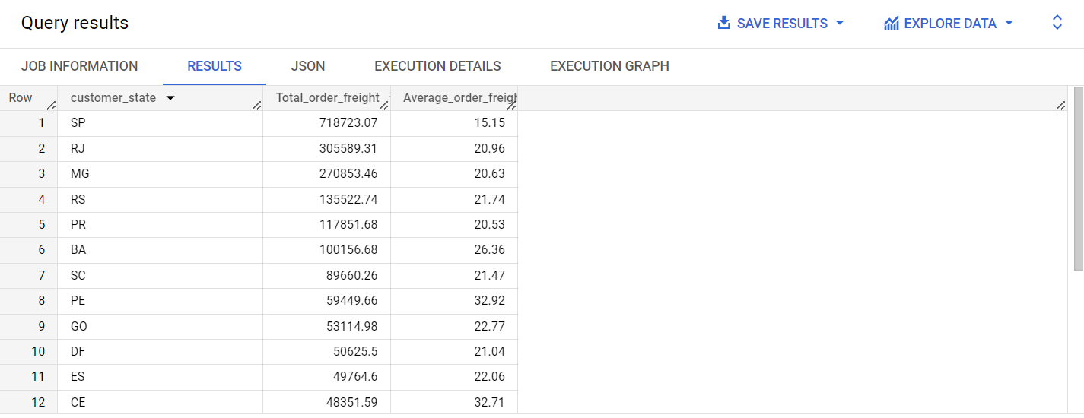

**Insights:**

The total and average freight value helps us in analysing the overall cost spent in shipping and delivering the order to its intended destination. If the freight cost is higher like for the state SP, some steps need to be implemented like revision or negotiation of prices with warehouse and shipping partners. The above data is sorted in descending order for both total and average order freight for each state.

**Q5. Analysis based on sales, freight and delivery time.**

1. **Find the no. of days taken to deliver each order from the order’s purchase date as delivery time.  
   Also, calculate the difference (in days) between the estimated & actual delivery date of an order.**Do this in a single query.  
     
   You can calculate the delivery time and the difference between the estimated & actual delivery date using the given formula:
   * time_to_deliver = order_delivered_customer_date - order_purchase_timestamp
   * diff_estimated_delivery = order_estimated_delivery_date - order_delivered_customer_date

**Query:**

SELECT

order_id,

DATE_DIFF(order_delivered_customer_date,order_purchase_timestamp, DAY) as time_to_deliver,

DATE_DIFF(order_estimated_delivery_date,order_delivered_customer_date, DAY) as diff_estimated_delivery

FROM `Target.orders`

WHERE order_delivered_customer_date IS NOT NULL

ORDER BY time_to_deliver DESC, diff_estimated_delivery DESC

**Output:**

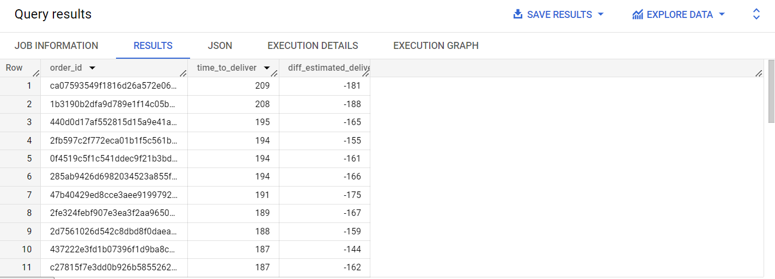

**Insights:**

This query and data set can provide us with several crucial insights. We get to know about the number of days taken for each order to get delivered. This helps in analysing the delays in the delivery process. Customers expect and appreciate timely delivery and delays in delivery can lead to dissatisfaction.

Also, when the delivery date is compared with estimated delivery date, we can analyse if the order was delivered before or after the suggested estimated delivery. We have calculated:

diff_estimated_delivery = order_estimated_delivery_date - order_delivered_customer_date

which is coming out to be negative.

1. **Find out the top 5 states with the highest & lowest average freight value.**

**Query:**

**Top 5 states with highest average freight value:**

SELECT

c.customer_state AS state,

ROUND(AVG(oi.freight_value),2) AS average_freight_value

FROM `Target.orders` AS o

INNER JOIN `Target.order_items` AS oi

ON o.order_id = oi.order_id

INNER JOIN `Target.customers` AS c

ON o.customer_id = c.customer_id

GROUP BY state

ORDER BY average_freight_value DESC

LIMIT 5

**Output:**

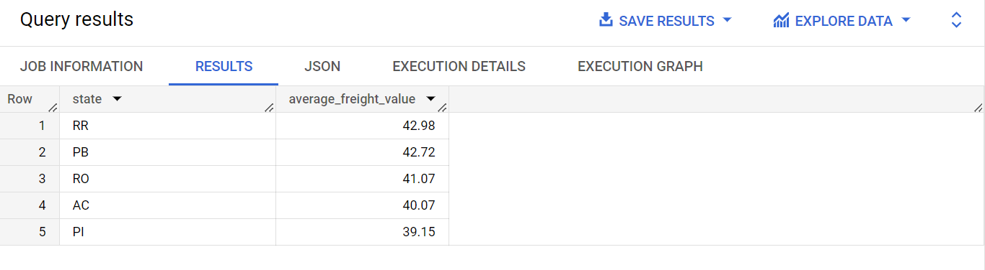

**Top 5 states with lowest average freight value:**

SELECT

c.customer_state AS state,

ROUND(AVG(oi.freight_value),2) AS average_freight_value

FROM `Target.orders` AS o

INNER JOIN `Target.order_items` AS oi

ON o.order_id = oi.order_id

INNER JOIN `Target.customers` AS c

ON o.customer_id = c.customer_id

GROUP BY state

ORDER BY average_freight_value ASC

LIMIT 5

**Output:**

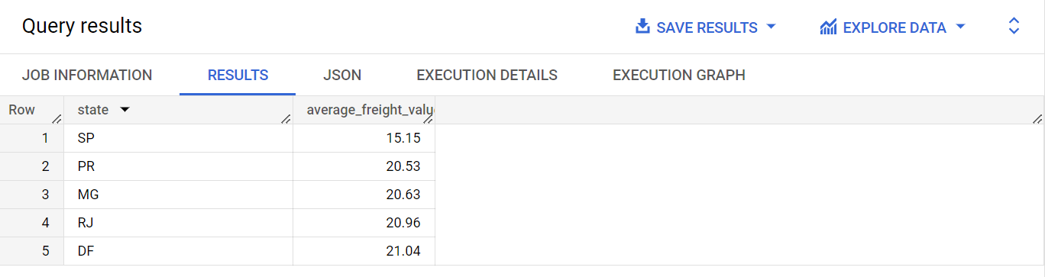

**Insights:**

From this analysis, we have the top 5 states with the highest and lowest average order freight value.We can study the shipping expenses and the strategies behind these. This will help in implementing the more advantageous cost distribution for the states with higher average order freight values.

1. **Find out the top 5 states with the highest & lowest average delivery time.**

**Query:**

**Top 5 states with highest average delivery time:**

SELECT

c.customer_state AS state,

ROUND(AVG(DATE_DIFF(o.order_delivered_customer_date, o.order_purchase_timestamp, DAY)),2) AS average_delivery_time

FROM `Target.orders` AS o

JOIN `Target.customers` AS c

ON o.customer_id = c.customer_id

GROUP BY state

ORDER BY average_delivery_time DESC

LIMIT 5

**Output:**

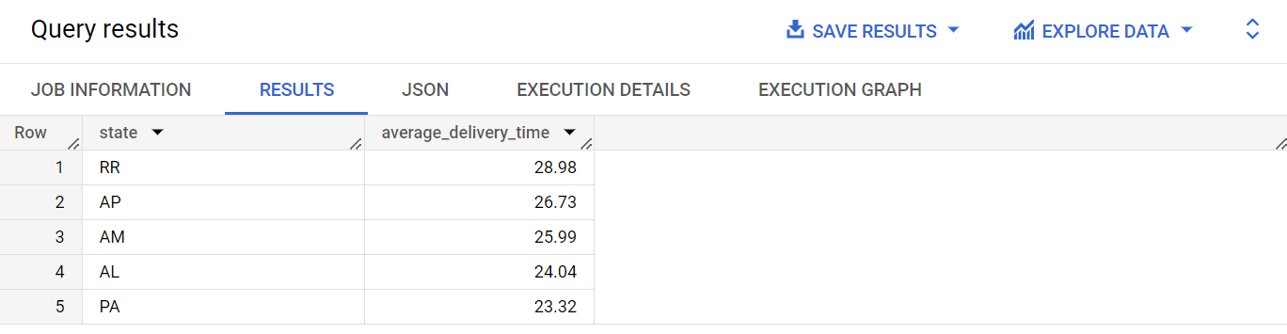

**Query:**

**Top 5 states with lowest average delivery time:**

SELECT

c.customer_state AS state,

ROUND(AVG(DATE_DIFF(o.order_delivered_customer_date, o.order_purchase_timestamp, DAY)),2) AS average_delivery_time

FROM `Target.orders` AS o

JOIN `Target.customers` AS c

ON o.customer_id = c.customer_id

GROUP BY state

ORDER BY average_delivery_time ASC

LIMIT 5

**Output:**

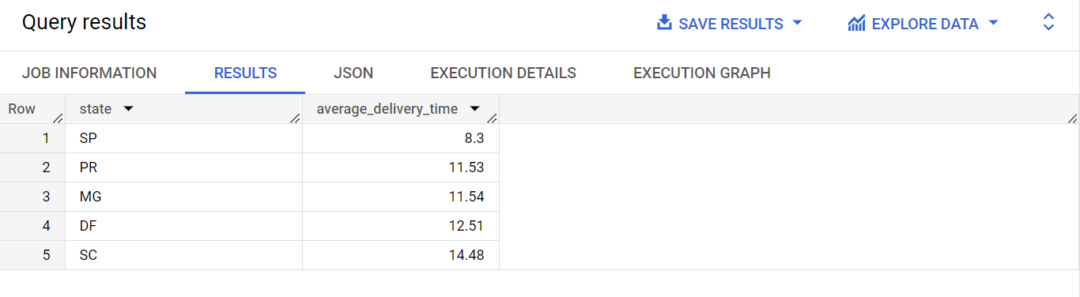

**Insights:**

From this analysis, we have the top 5 states with the highest and lowest average delivery time in days.As can be seen from the data, the least average delivery time is taken by the state SP and the highest average delivery time is taken by the state RR.

1. **Find out the top 5 states where the order delivery is really fast as compared to the estimated date of delivery.**  
   You can use the difference between the averages of actual & estimated delivery date to figure out how fast the delivery was for each state.

**Query:**

SELECT

c.customer_state,

ROUND(AVG(DATE_DIFF(o.order_delivered_customer_date, o.order_estimated_delivery_date, DAY)),2) AS avg_delivery_time

FROM `Target.orders` as o

JOIN `Target.customers` as c

ON o.customer_id = c.customer_id

GROUP BY c.customer_state

ORDER BY avg_delivery_time ASC

LIMIT 5

**Output:**

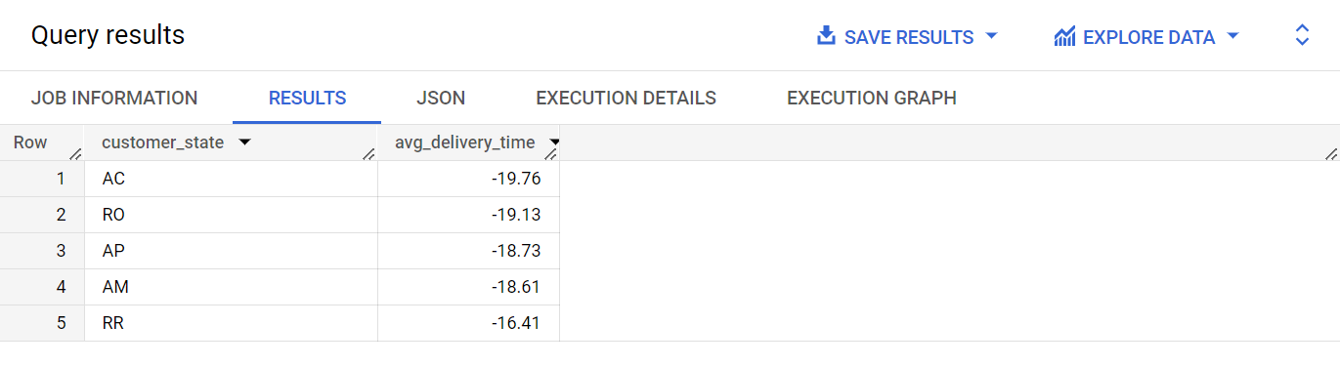

**Insights:**

We have calculated the top 5 states where the order delivery is really fast as compared to the estimated date of delivery.

The average delivery time is negative in the obtained data. A negative value indicates faster delivery. It is because in the query, it is calculated using the difference of delivery date and estimated delivery date.

This means that on average, the orders in those states are delivered earlier than the estimated delivery date.

Q6. **Analysis based on the payments:**

1. **Find the month on month no. of orders placed using different payment types.**

**Query:**

**Approach 1: Calculating the month on month number of orders placed using different payment types irrespective of the year**

SELECT

EXTRACT(MONTH from order_purchase_timestamp) AS Month,

p.payment_type,

COUNT(*) as orders_placed_per_month

FROM `Target.payments` as p

INNER JOIN `Target.orders` as o

ON p.order_id = o.order_id

INNER JOIN `Target.customers` as c

ON o.customer_id = c.customer_id

GROUP BY Month,p.payment_type

ORDER BY Month, p.payment_type

**Output:**

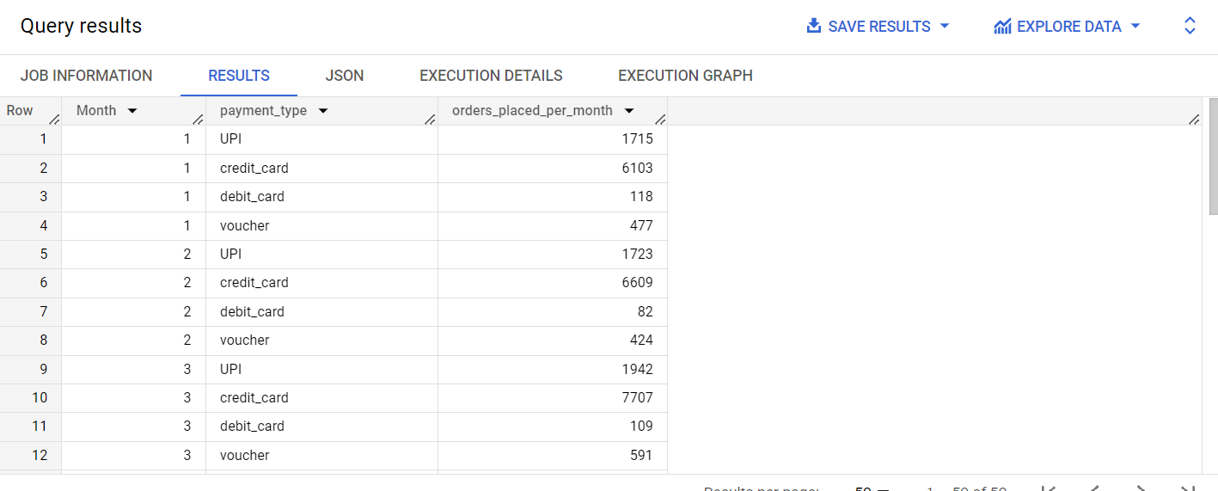

**Approach 2: Calculating the month on month number of orders placed using different payment types each year**

SELECT

EXTRACT(YEAR from order_purchase_timestamp) AS Year,

EXTRACT(MONTH from order_purchase_timestamp) AS Month,

p.payment_type,

COUNT(*) as orders_placed_per_month

FROM `Target.payments` as p

INNER JOIN `Target.orders` as o

ON p.order_id = o.order_id

INNER JOIN `Target.customers` as c

ON o.customer_id = c.customer_id

GROUP BY Year,Month,p.payment_type

ORDER BY Year,Month, p.payment_type

**Output**

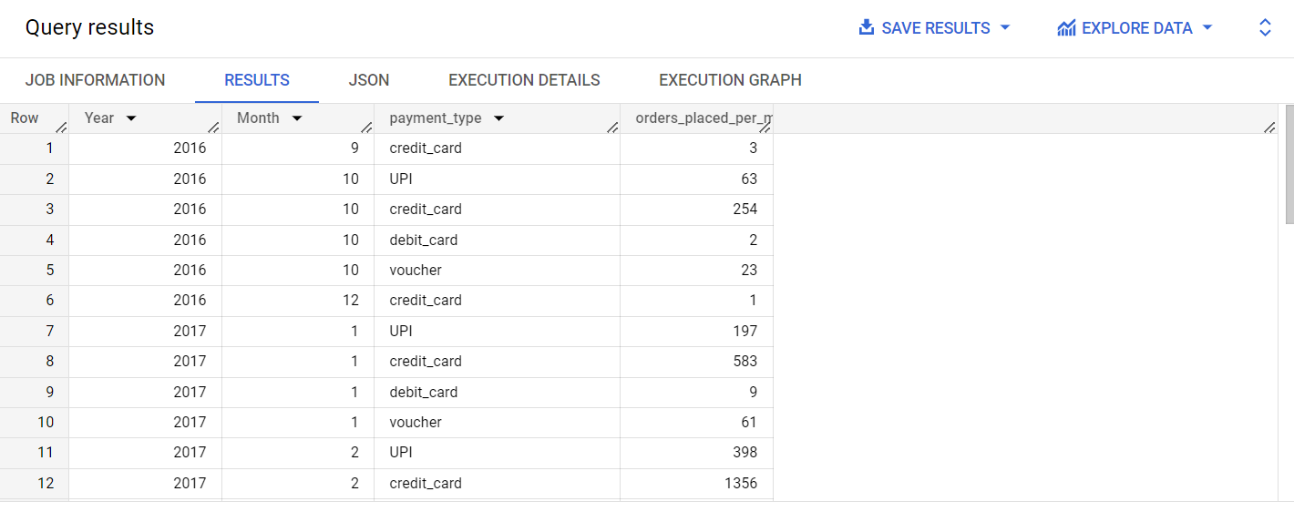

**Insights:**

Analysing the month on month number of orders placed using different payment modes like credit card, debit card, UPI, vouchers gives insights such as the payment type preferred by customers, payment trends, seasonal trend or partnerships.

From the obtained data, it can be seen that the number of transactions done using UPI is increasing significantly. This implies the preference of customers due to the ease in payment process.

It should also be noted that the transactions made from credit cards and vouchers are also increasing from month to month. This could be significantly due to the offers and discounts received in these modes of payments.

1. **Find the no. of orders placed on the basis of the payment installments that have been paid.**

**Approach 1: Calculating the overall number or orders irrespective of the payment installments type**

**Query:**

SELECT

count(DISTINCT order_id) as number_of_orders

FROM `Target.payments`

WHERE payment_installments >=1

**Output:**

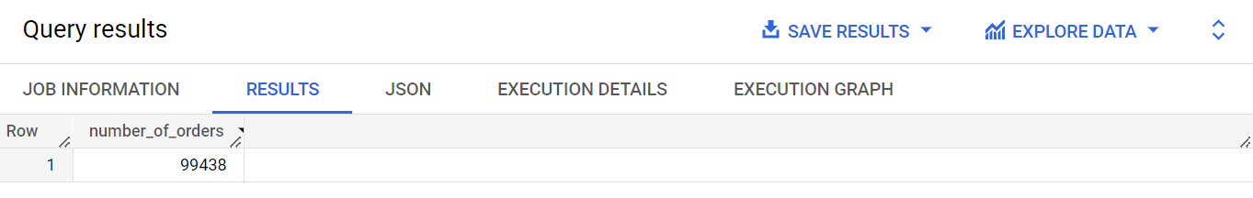

**Insights:**

The above data gives us the number of orders that have been paid on the basis of payment installments. The output is coming out to be 99438.

**Approach 2: Calculating the overall number or orders for each payment installments type**

**Query:**

SELECT

payment_installments,

count(DISTINCT order_id) as number_of_orders

FROM `Target.payments`

WHERE payment_installments >=1

GROUP BY payment_installments

ORDER BY number_of_orders

**Output:**

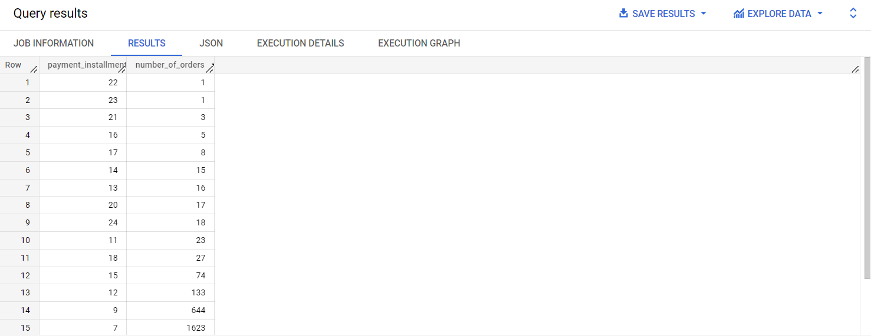

**//Extra Analysis**

**What is the review given by the customer for each product?**

**Query:**

SELECT

oi.product_id,

o.review_score,

o.review_comment_title

FROM `Target.order_reviews` as o

JOIN `Target.order_items` as oi

ON o.order_id = oi.order_id

ORDER BY o.review_score

**Output:**

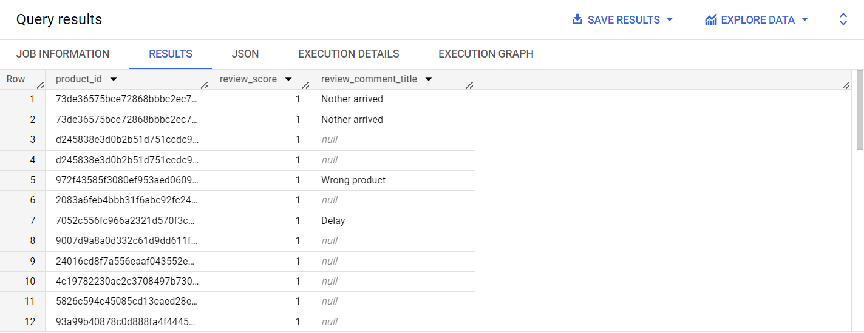

**Insights:**

The above data represents the review score and review given by the respective customers for every product. Review score can be from 1 to 5, 1 being the lowest.

**// Extra Data Analysis**

**We can also calculate the percentage increase in the number of orders placed from the year 2017 to 2018.**

**Query:**

SELECT

t.Year,

t.orders_placed_per_year,

(LAG(t.orders_placed_per_year) OVER(ORDER BY t.Year)) as previous_year_order,

ROUND(((t.orders_placed_per_year - (LAG(t.orders_placed_per_year) OVER(ORDER BY t.Year)))/ (LAG(t.orders_placed_per_year) OVER(ORDER BY t.Year)) * 100),2) as percentage_increase

FROM (

SELECT

EXTRACT(YEAR from order_purchase_timestamp) AS Year,

COUNT(*) as orders_placed_per_year

FROM `Target.orders`

GROUP BY Year

) t

WHERE t.Year = 2017 OR t.Year = 2018

ORDER BY t.Year

**Output:**

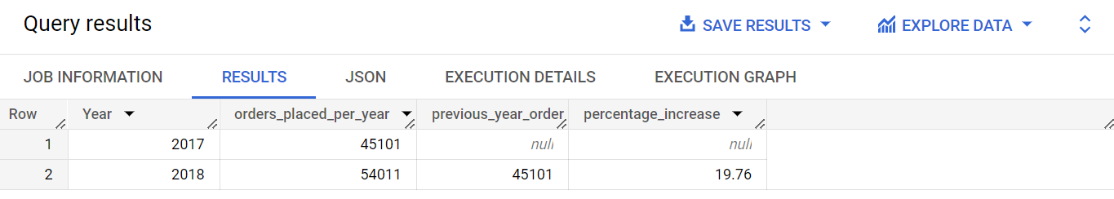

**Insights:**

The above output gives the percentage increase per year. There is an increase in the number of orders by 19.76% from the year 2017 to the year 2018.

**Actionable Insights & Recommendations**

We have analysed the data of the company Target in Brazil based on different factors. It is a company that offers a varied range of products including electronics, video games, kitchen appliances, kids games, beauty products, clothes, accessories and so much more.

* It can be observed that the number of orders placed by the customers is increasing per year.
* There is also a significant increase in the cost of orders from the year 2017 to 2018.

Let us draw actionable insights and recommendations based on other analysis as well:

* Let us consider the very first factor: **Average time of delivery in each state**

We have the data of top 5 states with the highest and lowest time of delivery. Consistency should be maintained for the states with fast delivery.

For the states taking longer time in delivering the products, assess the delivery process to identify the areas of improvements. Steps should be implemented for increasing the delivery speed including improving warehouse processes including storage, loading, packing, and shipping of goods and opting for a reliable delivery partner with a strong experience and planning on managing and transporting the orders as per their requirements. Alternative modes of transportations like trains should be considered wherever possible.

* Another factor to consider alongside this is the states with the highest & lowest **average freight value.**

The freight value refers to the cost involved in the shipping and transporting of goods from its original location to its final destination i.e. customer’s location.

Low freight value signifies lower cost shipment. This indicates the efficient transportation process and strong negotiating techniques with the carriers and transporters.

High freight value signifies the high cost of shipment. This will impact the profit made by the company. Improvements should be made by implementing steps like negotiating better with the carriers and transporting agents. Keep a record of how much capital is being invested at each step of the shipment process.

* Considering the **value of order price for each state** is another crucial factor. This gives insights on customer behaviour. We get to know how much the customer is willing to pay in different regions.

States with higher average order price values represent profitable markets with customers willing to pay more.

Conduct a market research on states with lower average order price values. Understand the needs of the customers and tailor the offerings based on that. Analyse and check if there is another potential competitor in the market and study their business strategies.

* We have analysed the **monthly seasonality trend** of the number of orders placed by the customers in Brazil. Insights from the observed trend can help plan upcoming months’ marketing plans, optimising inventory depending on the variation in orders placed by month.

If the number of orders placed for the next month is predicted to be significantly lower than the current month, then strategies to push more sales should be implemented to gain some percentage increase in the sales. This can be done by **collaborating** with other trending companies or respected public figures.

* The number of orders placed by the customers is also influenced by **the time of the day**, with the maximum in the afternoon and minimum at dawn hours.

Make sure that the process runs smoothly in the most active hours of the day. For an offline store, staff should be very well trained and an adequate number of sales teams should be present to help customers. For an online platform, it should be made sure that search engine optimization is smooth and interactive and the site will not crash with increased engagement.

Also, at the comparatively less active hours, we can experiment and try to increase the activity by launching something distinct at the company’s platform. This can include the launch of a new product, limited time offers or sales**.** Maximum offers should be pushed at these hours to gain even more activity.

* **Customer is the core of our company**.

We have gained insights on the number of **customers distributed across each geographical region.** This provides valuable information about the distribution of customers in different states of Brazil. In states like RR with particularly less number of customers, conduct a thorough market research on customers preferences.

The company should develop personalised discounts and offers, particularly for the states with lesser number of customers to increase the customer reach**.** Moreover, Enhance the online presence by utilising digital marketing platforms like varied social media platforms to advertise and reach the potential audience.

* We have also learned about the seasonal demands in each region of Brazil. To improve the decline in the numbers of orders placed each month for a specific region or state, it should be thoroughly investigated.

**Customer’s feedback** is the most valuable asset for any company. Take feedback and reviews from your customers and resolve the issues with the best suited strategy they are facing, if any. Try giving them exciting offers to show the sincerity of a brand towards its customers and to make them feel valued along with exceptional in-store experience to attract and gain customers.

Take inspiration from the regions with increasing or consistent growth of sales per month.

* We have the data of **reviews provided by the customers** for each product they bought. It is very essential for the company to go through those reviews and work on those accordingly. If a customer is not satisfied with the service provided, alternatives like exchange and return of the ordered products, or complimentary gifts should be provided. The aim should be to resolve all the customer’s concerns.
* Interaction with customers can be increased by collaborating with influencers on platforms like Instagram. This can elevate the customer reach even more if **competitions are launched with exciting offers and gifts in return.** Use appropriate hashtags and marketing platforms for the same.
* One of the other ways to make the ordering process **more smooth and streamline** for customers is to **work on the payment methods** used to complete an order. As observed, UPI, credit card and vouchers were gaining more popularity among customers. Try establishing partnerships with those payment providers for a convenient checkout experience.
* Implement initiatives like use of biodegradable bags instead of plastic bags in the stores. Many customers appreciate and support the efforts made by the companies to save the environment.